The AppOwnsDataMultiTenant Application

The **AppOwnsDataMultiTenant** application is a sample .NET 6 application which demonstrates how to design an App-Owns-data application using the **service principal profiles** feature introduced in the Power BI Service in March of 2022. This article explains how service principal profiles can be used to design and implement a large-scale, multitenant environment for Power BI embedding with 10,000's or 100,000's of customer tenants.

This article will began with a quick primer on developing multitenant application using App-Owns-Data embedding. This primer will allow the reader to better understand the problems that service principal profiles were created to solve. Next, this article will introduce service principal profiles and explain how they can be used to improve performance, scalability and security in a multitenant application that has been developed using App-Owns-Data embedding.

The article also contains step-by-step instructions to set up the **AppOwnsDataMultiTenant** application to get it up and running in a Power BI development environment.

Table of Contents

Developing Multitenant Applications for App-Owns-Data Embedding 2

Understanding the 1000 Workspace Limitation 2

Managing Isolation for Datasets and Datasource Credentials 3

Design Strategies Before Service Principal Profiles 4

Introduction to Service Principal Profiles 5

Service Principal Profiles are Power BI Security Principals 6

Executing Power BI REST API Calls as a Service Principal Profile 6

Using the Profiles API to create and manage service principal profiles 7

Getting Started with the **AppOwnsDataMultiTenant** application 10

Setting up your development environment 11

Create an Azure AD security group named Power BI Apps 11

Configure Power BI tenant-level settings for service principal access 12

Create the Azure AD Application for the AppOwnsDataMultiTenant Application 15

Test the Tenant Management project in Visual Studio 2022 19

Download the Source Code 19

Open the Project in Visual Studio 2022 20

Update application settings in the appsettings.json file 21

Create the AppOwnsDataMultiTenantDB database 22

Test the Tenant Management Application 25

Create App Identities 26

Create New Power BI Tenants 28

Embed Reports 31

Inspect the Power BI Workspaces 32

Create a Separate Service Principal for Each Tenant 33

## Developing Multitenant Applications for App-Owns-Data Embedding

If you have experience working with Azure AD, the word **"tenant"** might make you think of an Azure AD tenant. However, the concept of a tenant is different when talking about building a multitenant environment for Power BI embedding. In this context, each tenant is created on behalf of a customer for which you are embedding Power BI reports using the App-Owns-Data embedding model.

In order to create a scalable multitenant environment, you must be able to automate the creation of new customer tenants. Provisioning a new customer tenant typically involves writing code which calls the Power BI REST API to create a new Power BI workspace, import PBIX files, update datasource parameters, set datasource credentials and start dataset refresh operations. The following diagram depicts how Power BI artifacts such as reports and datasets can be added into workspaces to create customer tenants.

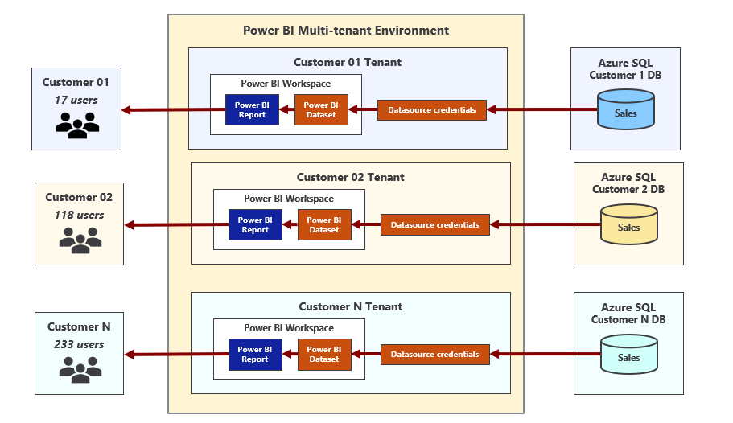

When developing an application that implements App-Owns-Data embedding, it’s possible to call the Power BI REST API under the identity of a master user account or under the identity of a service principal. However, Microsoft strongly recommends using a service principal. By using a service principal, you can avoid common problems associated with master user accounts such as experiencing authentication errors in environments where users are required to log in using multi-factor authentication (MFA). Using a service principal is also consistent with the idea that App-Owns-Data embedding is based on leverages under a Platform as a Service (PaaS) mindset as opposed to a Software as a Service (SaaS) mindset.

### Understanding the 1000 Workspace Limitation

When designing a multitenant environment for App-Owns-Data embedding, there is a documented limitation that requires your attention. In particular, the limitation is that neither a user nor a service principal can be member of more than 1000 workspaces. The purpose of this limitation has to do with performance. The limitation exists to ensure code paths don't become inefficient resulting in performance degradation. At little background might make it easier for you to understand what's involved.

Behind the scenes, the Power BI Service maintains a set of security-related metadata for each service principal. The Power BI Service uses this metadata to track which workspaces and artifacts the service principal can access. In effect, the Power BI Service maintains a separate access control list (ACL) for each service principal as part of its authorization subsystem.

When a service principal calls the Power BI REST API to access a workspace, the Power BI service runs an security check against the service principal's ACL to ensure it has the proper authorization. As you can imagine, the time it takes to determine whether the target workspace ID is inside the ACL increases as the number of workspaces increases. The Power BI team created and documented the 1000-workspace limitation to ensure the authorization metadata (i.e. ACL) for a service principal (or user) doesn't grow so large that it significantly degrades performance.

The 1000-workspace limitation isn’t enforced through code in the Power BI Service. If you try, you'll find you can create 1,200 workspaces using a single service principal. When you cross over the line from 1000 to 1001 workspaces, nothing really changes. Calls from the service principal to the Power BI REST API will still execute successfully. However, it's important to acknowledge that the application has moved into an "unsupported" state which has implications when trying to get help from Microsoft support.

To summarize, the scenario in which a service principal owns 1000 workspaces or less is supported. The scenario in which a service principal owns 1001 workspaces or more is unsupported. Let's look at a simple example to make an additional point.

Consider a scenario in which two multi-tenant applications have each been implemented to use a single service principal. Now imagine the first application has created 990 workspaces while the second application has created 1010 workspaces. From a supportability standpoint, the first application is within the supported boundaries while the second application is not.

Now let's compare these two applications purely from a performance point of view. There's really not that much difference because the ACLs for both service principals have let the metadata for their ACLs grow to a point where it will degrade performance to some degree.

Here's the key observation. The number of workspaces created by a service principal has a direct effect on performance. A service principal which is a member of 100 workspaces will execute calls on the Power BI REST API faster than a service principal which is a member of 1000 workspaces. Likewise, a service principal which is a member of only 10 workspaces will execute calls faster than a service principal which is a member of 100 workspaces. From the perspective of performance and scalability, the optimal number of workspaces in which a service principal should be a member is 1.

### Managing Isolation for Datasets and Datasource Credentials

Another important aspect of designing an App-Owns-Data embedding application for a multitenant environment has to do with maintaining the required level of isolation across customer tenants. The last thing you want is for a user in one customer tenant to see data from another tenant that belongs to a different customer. Therefore, it's critical that you understand how datasets and datasource credentials are managed within the Power BI Service.

Each dataset in the Power BI Service has an owner which can be either a user or a service principal. You can discover who the dataset owner is by inspecting the **ConfiguredBy** property in the dataset settings page. You can perform a Take Over action to transfer dataset ownership from one user or service principal to another. If you import a PBIX file to create a new dataset using a service principal, the service principal is automatically configured as the dataset owner.

In order to connect a dataset to its underlying datasource, the dataset owner must set dataset credentials. These datasource credentials are then cached by the Power BI Service in an encrypted fashion. After that point, the Power BI Service is then able to use those credentials to authenticate with the underlying datasource when refreshing the data in an import-mode dataset or when executing a query with a DirectQuery dataset.

There is a common pattern used by developers when provisioning a new customer tenant where the application executes a series of calls all running as a service principal. The first call creates a new workspace. The second call associates that workspace with a dedicated capacity. Next, there is a call to import a PBIX file to create a new dataset. After importing a PBIX file to create a dataset, a service principal can then set the dataset source credentials for that dataset. As a result of these Power BI REST API calls, the service principal is an Admin of the new workspace and the owner of the dataset and the datasource credentials.

A common misconception is that datasource credentials in the Power BI Service are scoped at the workspace level. They are not. Instead, datasource credentials are scoped by user or by service principal and their scope extends across all Power BI workspaces in the current Azure AD tenant. It's possible for a service principal to create datasource credentials that are used by datasets in different workspaces as shown in the following diagram.

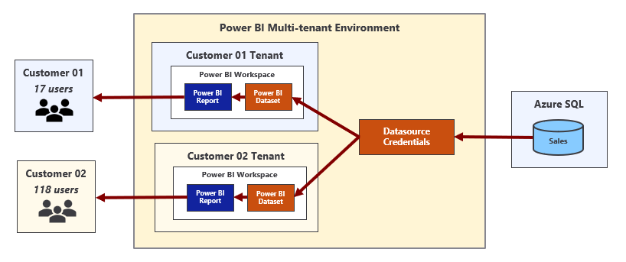

### Design Strategies Before Service Principal Profiles

In this section, we will quickly review the three common design strategies that have been used to build and manage multitenant environments for App-Owns-Data embedding. This give you a better appreciation of the design problems that service principal profiles feature was designed to solve.

Prior to the introduction of service principal profiles, developers have built multitenant applications with support for App-Owns-Data embedding using one the following three design strategies.

* Single service principal
* Service principal pooling
* One service principal per workspace

Now let's review the strengths and weakness of each of these design strategies starting with single service principal. When an application is designed to use a single service principal, it requires a one-time creation of Azure AD application for service principal. Therefore, it requires less administrative overhead than the other two strategies because there is no ongoing need to create new Azure AD applications in order to add more service principals. It is also the easiest strategy to implement as the other two strategies require extra code to switch the calling context between service principals when calling the Power BI REST API.

The obvious problem with the single service principal design strategy is it doesn't scale. It only supports a multitenant environment that can grow to no larger than 1000 workspaces. The application will also be less performant as the service principal becomes a member of a large number of workspaces. Finally, there is a problem with customer tenant isolation because there is a single service principal that will be the owner of every dataset and all data credentials across all customer tenants.

Service principal pooling provides a commonly-used strategy to get around the 1000-workspace limitation. The main idea is that the application can scale to any number of required workspaces by adding the correct number of service principals to the pool. For example, a pool of 5 service principals makes it possible to scale up to 5,000 workspaces. A pool of 80 service principals makes it possible to scale up to 80,000 workspaces.

While service principal pooling can scale to a large number of workspaces, it has several disadvantages. First, it requires extra code and metadata to implement context switching between service principals when calling the Power BI REST API. Second, there is more administrative overhead as it will be necessary to create new Azure AD applications whenever it's necessary to increase the number of the service principals in the pool.

The service principal pooling strategy is not optimized for performance because it allows service principals to become members of 100s of workspaces. It also is not ideal from the perspective of customer tenant isolation. While it's slightly better than the single service principal strategy, there is still the issue where each service principal will the the owner of datasets and datasource credentials across many different customer tenants.

The final strategy is the one that involves creating a new service principal for each new customer tenant. From a theoretical standpoint, this is the best solution because it optimizes the performance of calls to the Power BI REST API while also providing true isolation for datasets and datasource credentials at the workspace level. However, what works best in theory doesn't always work best in practice. This is a good example.

The strategy of creating a new service principal for each new customer tenant is impractical for most large organizations. That's because these organizations require formal approval processes or they introduce other bureaucratic red tape for creating new Azure AD applications. This makes it impossible to grant a custom application the authority it needs to create new Azure AD applications on-demand in an automated fashion which is a requirement when using this strategy.

In less common scenarios where a custom application is granted the proper permissions, it can use the Microsoft Graph API to create new Azure AD applications on demand. This type of custom application becomes more complex to develop and deploy because it must somehow track credentials for each Azure AD application and gain access to those credentials whenever it needs to authenticate and acquire access tokens for individual service principals. The [TenantManagement](https://github.com/PowerBiDevCamp/TenantManagement) sample application demonstrates using this approach.

## Introduction to Service Principal Profiles

The previous section discussed three essential problems that need to be addressed when developing a multitenant application that uses App-Owns-Data embedding. Here is a summary of those three problems.

1. Scaling to a large number of workspaces
2. Optimizing performance in calls to the Power BI REST API
3. Isolating datasets and datasource credentials at the customer tenant level.

The Power BI embedding team created the service principal profiles feature to solve these three problems with the lowest amount of developer effort and overhead. As you will see, designing a multitenant application using service principal profiles will combine the strengths of the three design strategies discussed in the previous section while avoiding the weaknesses. Now it's time to drill down into a discussion about how service principal profiles work.

Service principal profiles are local accounts which are created within the context of the Power BI Service. A service principal can use the new [Profiles](https://docs.microsoft.com/en-us/rest/api/power-bi/profiles) endpoint of the Power BI REST API to create new service principal profiles. This makes it possible for a service principal to create and managed its own set of service principal profiles for a custom application as shown in the following diagram.

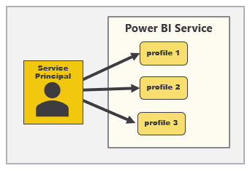

Later in this article, you will learn how to write code to create service principal profiles as well as how to execute Power BI REST API calls under the identity of a service principal profile. However, it's now time to make a general observation. While the service principal itself and its underlying Azure AD application are known to Azure AD, Azure AD doesn't know anything about service principal profiles. Instead, service principal profiles are created by the Power BI Service and they only exist within the context Power BI Service subsystem which controls security and authorization.

There will always be a parent-child relationship between a service principal and the service principal profiles it creates. A service principal profile can never be created as a stand-alone entity. Instead, each service principal profile must be created by specific service principal and that service principal will serve as the profile's parent. Furthermore, a service principal is never visible to users or other service principals. A service principal profile can only be seen and used by the service principal that created it.

### Service Principal Profiles are Power BI Security Principals

The second important observation is that a service principal profile is first-class security principal in the Power BI authorization system. The Power BI Service treats a service principal profile like a user or a service principal in the sense that a profile can be added to a workspace as a member. A service principal profiles can also be the owner of a dataset and the owner of datasource credentials. This leads to the best practice of creating a new service principal profile for each new customer tenant as shown in the following diagram.

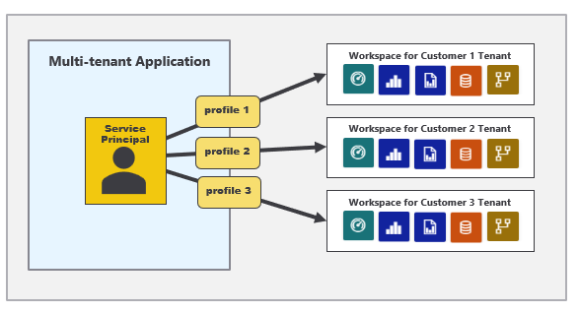

When you develop a custom application using service principal profiles, you only need a single Azure AD application which provides your application with a single service principal. This lowers administrative overhead compared to previous strategies because there is no ongoing need to create additional Azure AD applications after the application goes into production.

### Executing Power BI REST API Calls as a Service Principal Profile

There is one more essential concept to understand when developing a multitenant application with service principal profiles. More specifically, you can execute Power BI REST API calls under the identity of a service principal profile. That means you can execute the sequence of API calls under the identity of a service principal profile when provisioning a new customer tenant. Let's examine this in a little more detail.

If you execute a Power BI REST API call under the identity of a service principal profile to create a new workspace, that profile will automatically be configured as a workspace member in the role of Admin. If you execute a call under the identity of a service principal profile to import a PBIX file and create a dataset, that profile will be configured as the dataset owner. If you execute call under the identity of a service principal profile to set datasource credentials, the profile will be configured as the owner of the datasource credentials.

Programming with service principal profiles might seem a little complicated at first. You can execute API calls under the identity of a service principal profile and you can also execute a call without a profile which will execute under the identity of the service principal. It's important to understand that a service principal has an identity in the Power BI Service that is separate and distinct from the identities of its profiles.

Now it's time to focus on how to program when developing a multitenant application using service principal profiles. When do you execute Power BI REST API calls as the parent service principal versus when do you execute API calls a child service principal profile? It turns out this isn’t too complicated once you understand the basic pattern.

You should execute API calls as the service principal when you are creating, viewing and deleting service principal profiles. However, most of the other API calls should be executed as a service principal profile. This includes API calls to create workspaces and import PBIX files. It also includes API calls to update dataset parameters and to set datasource credentials. Finally, it includes API calls to query for workspace artifacts and to generate embed tokens.

Let's look at a basic example. Imagine you need to create a new customer tenant for a customer named Wingtip. The first step is to execute an API call to create a new service principal profile with a display name of Wingtip. That first call is made under the identity of the service principal. However, all the remaining Power BI REST API calls shown in the following list should be made under the identity of the service principal profile that has just been created.

* Create workspace
* Associated workspace with capacity
* Import PBIX
* Update dataset parameters
* Set credentials
* Start refresh

It's now time to make final observation. Each customer tenant is built using a Power BI workspace and a set of artifacts that are all owned and managed by one specific service principal profile. In order to access that Power BI workspace and its content at a later time, you must execute API calls using the identity of the same service principal profile that was used to create the customer tenant.

And what about the service principal itself? Does the service principal require any access to the workspaces for customer tenants and the content inside? The answer is no, the service principal itself doesn't need any access at all. Remember, Power BI REST API calls executed under the identity of the service principal are mainly to create and manage service principal profiles. All workspace creation and content access is done using service principal profiles.

### Using the Profiles API to create and manage service principal profiles

The Power BI embedding team has introduced a new **Profiles** API which is used to create and manage service principal profiles. You can find the documentation to the **Profiles** API at the following URL.

**https://docs.microsoft.com/en-us/rest/api/power-bi/profiles**

The Profiles API contains the following operations.

* Create Profile
* Delete Profile
* Get Profile
* Get Profiles
* Update Profile

Let's begin by looking at the Create Profile operation. The following table shows the details required for executing an HTTP POST request against the **Profiles** endpoint to create a new service principal profile.

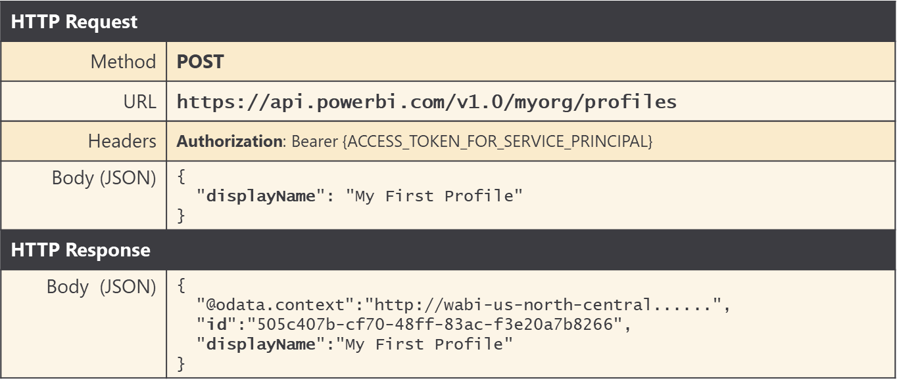

Note that you must pass a **displayName** property in the request body to provide a display name for the new tenant. The **displayName** must be unique across all the profiles owned by a specific service principal.

The API call to create a new service principal profile returns which a GUID in the **id** property which represents the profile id. In an application that uses service principal profiles, it's a best practice to display profile names and ids in a custom database so the application can lookup the id for a service principal profile when that's required.

If you are programming with the Power BI .NET SDK, you can call **Profile.CreateProfile** using the following code.

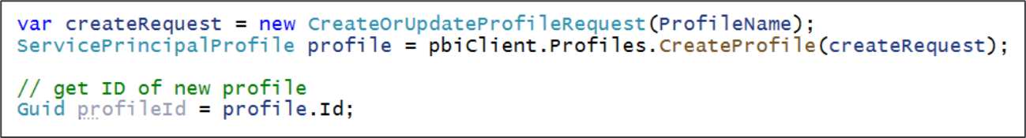

When you need to delete a service principal profile, you can execute an HTTP DELETE operation in which the profile id is parsed into the end of the URL.

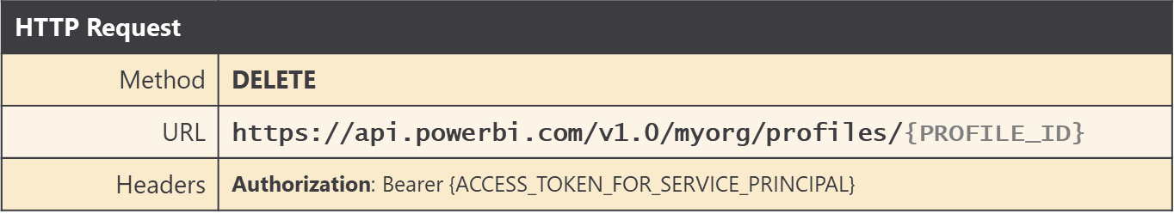

If you are programming with the Power BI .NET SDK, you can call **Profile.DeleteProfile** using the following code.



Ss

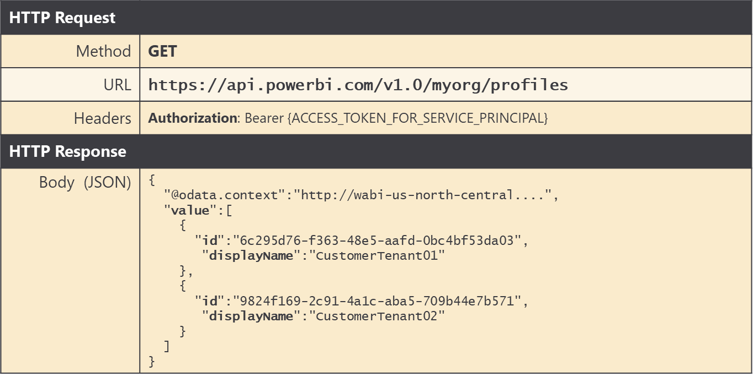

C



X

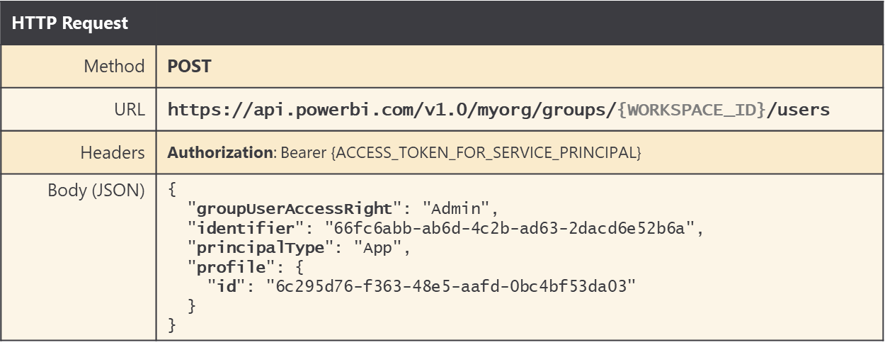

X

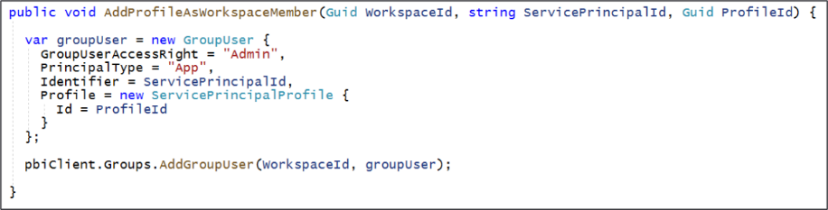

Xx



X

Calling

Xxxx pass header

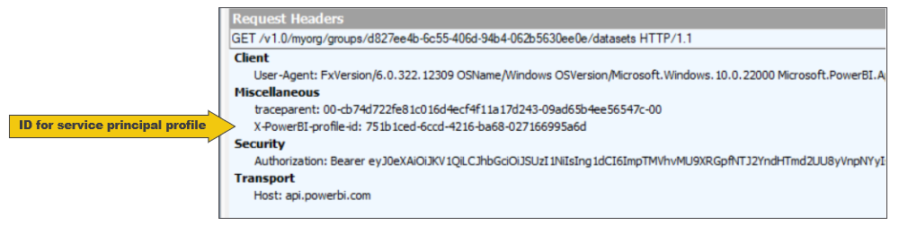

x

## Getting Started with the **AppOwnsDataMultiTenant** application

The **AppOwnsDataMultiTenant** application demonstrates how to manage a multitenant environment for Power BI embedding using service principal profiles. This sample application has been designed to use the best practice of creating a separate service principal profile for each new customer tenant. This design strategy optimizes calls to the Power BI REST API while also providing dataset and datasource credential isolation at the customer tenant level. The design of the **AppOwnsDataMultiTenant** application also makes it possible to scale upwards to manage an environment with up to and beyond 100,000 customer tenants.

the **AppOwnsDataMultiTenant** application provides a screen

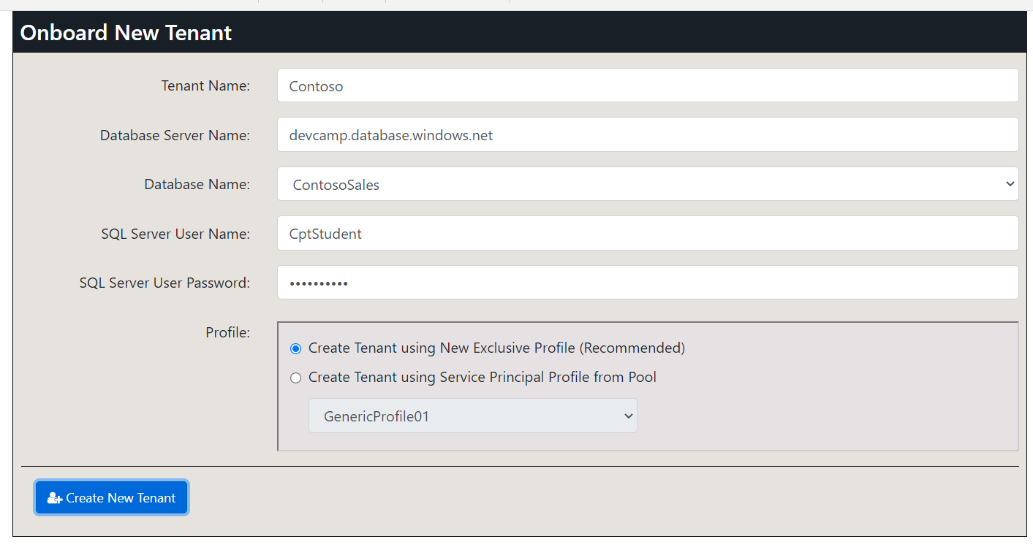

When you click the **Create New Tenant** button, the application executes code which begins by creating a new service principal profile using the same name as the **Tenant Name**. After creating the service principal profile, the application then switches contexts and begins calling the Power BI REST API using that profile's identity to provision customer tenants. This application design maintains a one-to-one relationship between service principal profiles and customer tenant workspaces which is what Microsoft recommends as a best practice.

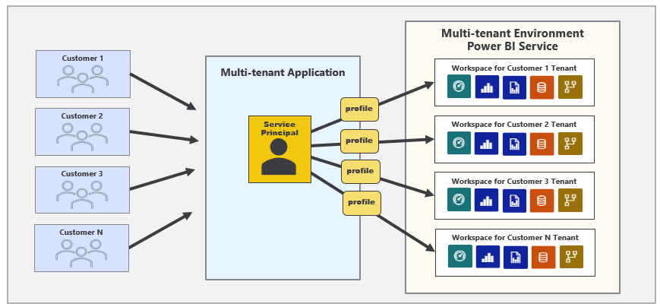

The **AppOwnsDataMultiTenant** application demonstrates code which authenticates with Azure AD to acquire access tokens used to call the Power BI REST API as a service principal or as a service principal profile. However, this application was designed as a proof-of-concept (POC) and, consequently, it does not provide any logic to authenticate or authorize the user authentication. If you are going to use the **AppOwnsDataMultiTenant** application as a starting point for something building, it will be your responsibility to add in the code required to authenticate and authorize users who will be responsible for creating and managing customer tenants.

### Setting up your development environment

You can follow the steps in this section to set up the **AppOwnsDataMultiTenant** application for testing. To complete these steps, you will require a Microsoft 365 tenant in which you have permissions to create and manage Azure AD applications and security groups. You will also need Power BI Service administrator permissions to configure Power BI settings to give service principals to ability to access the Power BI Service API. If you do not have a Microsoft 365 environment for testing, you can create one for free by following the steps in [Create a Development Environment for Power BI Embedding](https://github.com/PowerBiDevCamp/Camp-Sessions/raw/master/Create%20Power%20BI%20Development%20Environment.pdf).

To set up the **AppOwnsDataMultiTenant** application for testing, you will need to configure a Microsoft 365 environment by completing the following tasks.

1. Create an Azure AD security group named **Power BI Apps**
2. Configure Power BI tenant-level settings for service principal access
3. Configure Power BI tenant-level settings to enable service principal profiles
4. Create the Azure AD Application for the **AppOwnsDataMultiTenant** Application

The following three sections will step through each of these setup tasks.

### Create an Azure AD security group named Power BI Apps

Begin by navigating to the [Groups management page](https://portal.azure.com/#blade/Microsoft_AAD_IAM/GroupsManagementMenuBlade/AllGroups) in the Azure portal. Once you get to the **Groups** page in the Azure portal, click the **New group** link.

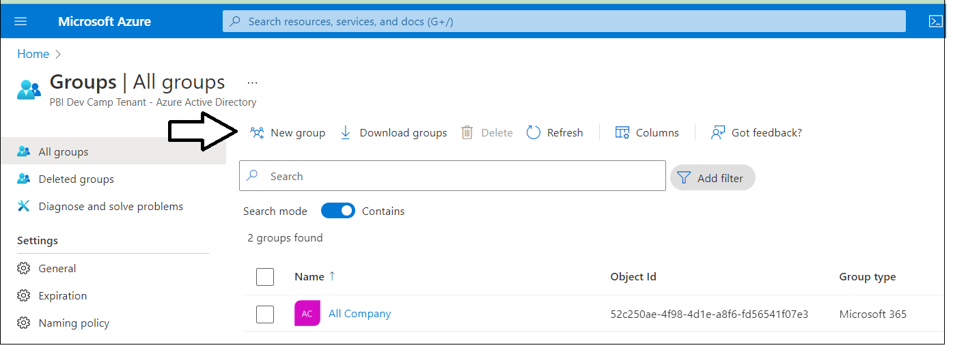

In the **New Group** dialog, Select a **Group type** of **Security** and enter a **Group name** of **Power BI Apps**. Click the **Create** button to create the new Azure AD security group.

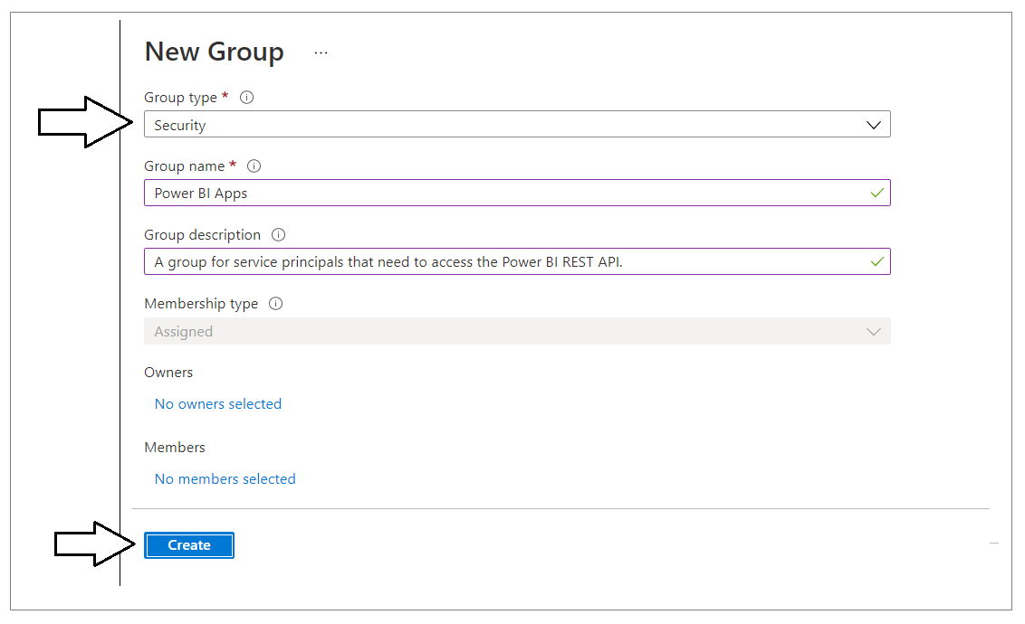

Verify that you can see the new security group named **Power BI Apps** on the Azure portal **Groups** page.

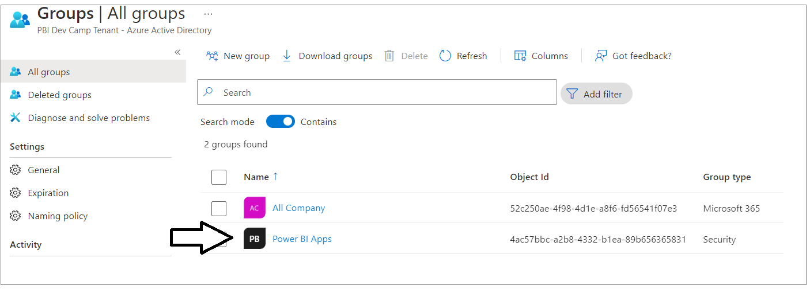

### Configure Power BI tenant-level settings for service principal access

Next, you need you enable a tenant-level setting for Power BI named **Allow service principals to use Power BI APIs**. Navigate to the Power BI Service admin portal at <https://app.powerbi.com/admin-portal>. In the Power BI Admin portal, click the **Tenant settings** link on the left.

](https://github.com/PowerBiDevCamp/TenantManagement/blob/main/Images/ReadMe/media/image4.png)

Move down in the **Developer settings** section and expand the **Allow service principals to use Power BI APIs** section.

](https://github.com/PowerBiDevCamp/TenantManagement/blob/main/Images/ReadMe/media/image5.png)

Note that the **Allow service principals to use Power BI APIs** setting is initially set to **Disabled**.

](https://github.com/PowerBiDevCamp/TenantManagement/blob/main/Images/ReadMe/media/image6.png)

Change the setting to **Enabled**. After that, set the **Apply to** setting to **Specific security groups** and add the **Power BI Apps** security group as shown in the screenshot below. Click the **Apply** button to save your configuration changes.

](https://github.com/PowerBiDevCamp/TenantManagement/blob/main/Images/ReadMe/media/image7.png)

You will see a notification indicating it might take up to 15 minutes to apply these changes to the organization.

](https://github.com/PowerBiDevCamp/TenantManagement/blob/main/Images/ReadMe/media/image8.png)

Now look down in the **Tenant setting** section of the Power BI admin portal and locate **Workspace settings**

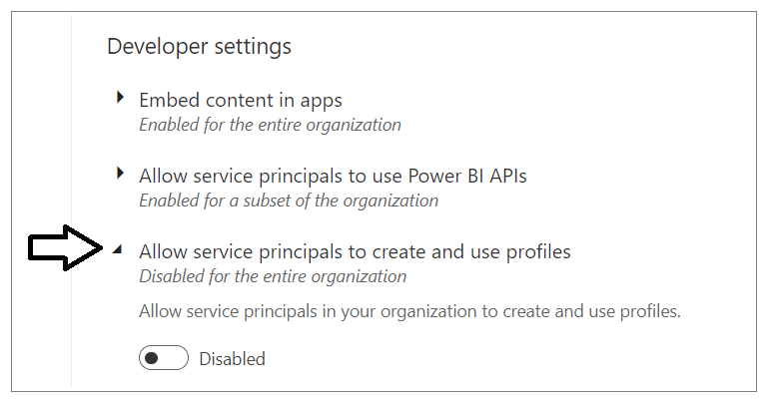

Xxxx

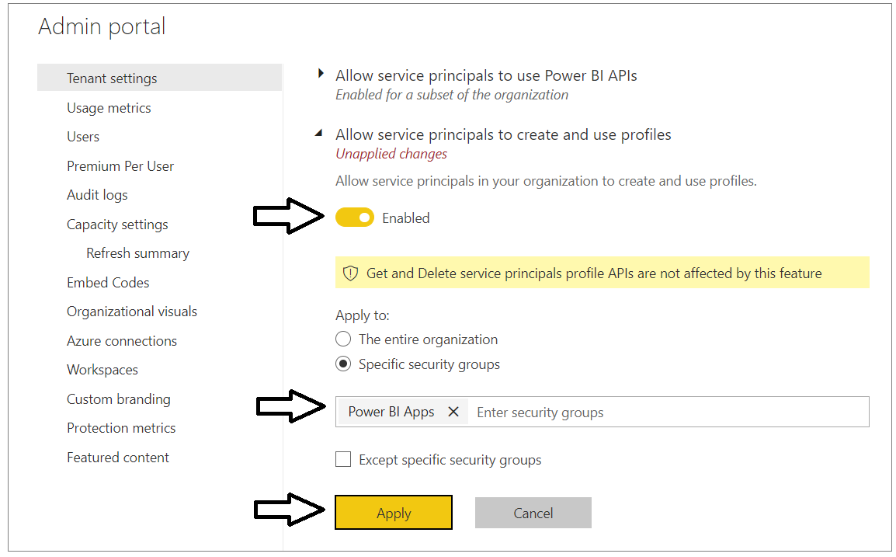

Now scroll upward in the **Tenant setting** section of the Power BI admin portal and locate **Workspace settings**.

](https://github.com/PowerBiDevCamp/TenantManagement/blob/main/Images/ReadMe/media/image9.png)

Note that a new Power BI tenant has an older policy where only users who have the permissions to create Office 365 groups can create new Power BI workspaces. You must reconfigure this setting so that service principals in the **Power BI Apps** group will be able to create new workspaces.

](https://github.com/PowerBiDevCamp/TenantManagement/blob/main/Images/ReadMe/media/image10.png)

In **Workspace settings**, set **Apply to** to **The entire organization** and click the **Apply** button to save your changes.

](https://github.com/PowerBiDevCamp/TenantManagement/blob/main/Images/ReadMe/media/image11.png)

You have now completed the configuration of Power BI tenant-level settings.

### Create the Azure AD Application for the ****AppOwnsDataMultiTenant**** Application

Login to the Azure portal to create the new Azure AD application. Begin by navigating to the [App registration](https://portal.azure.com/#blade/Microsoft_AAD_IAM/ActiveDirectoryMenuBlade/RegisteredApps) page in the Azure portal and click the **New registration** link.

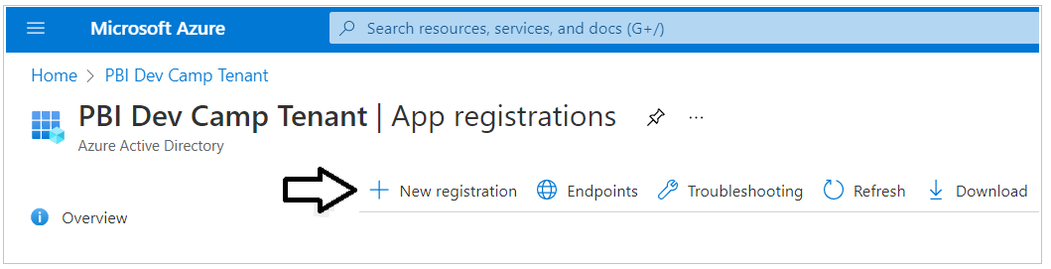

On the **Register an application** page, enter an application name such as **Power BI Embedding Tenant Manager** and accept the default selection for **Supported account types** of **Accounts in this organizational directory only**.

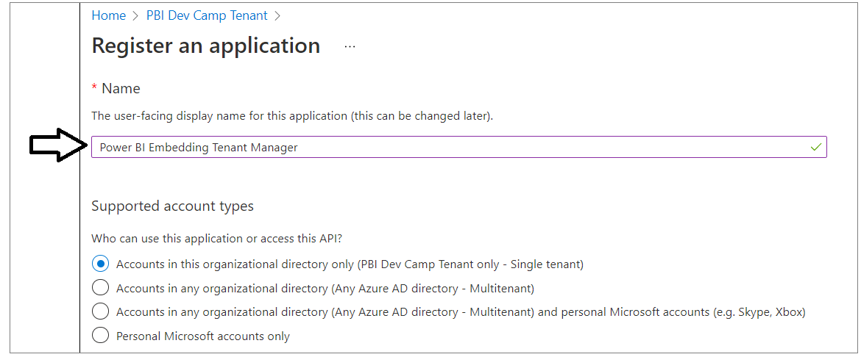

Complete the following steps in the **Redirect URI** section.

1. Set the dropdown selection of **Web** in the dropdown box
2. Do not enter a value for the **Redirect URI**. Leave it blank.
3. Click the **Register** button to create the new Azure AD application.

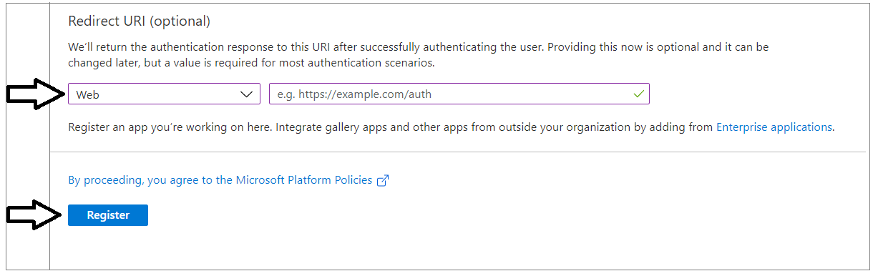

After creating a new Azure AD application in the Azure portal, you should see the Azure AD application overview page which displays the **Application ID**. Note that the ***Application ID*** is often called the ***Client ID***, so don't let this confuse you. You will need to copy this Application ID and store it so you can use it later to configure the project's support for Client Credentials Flow.

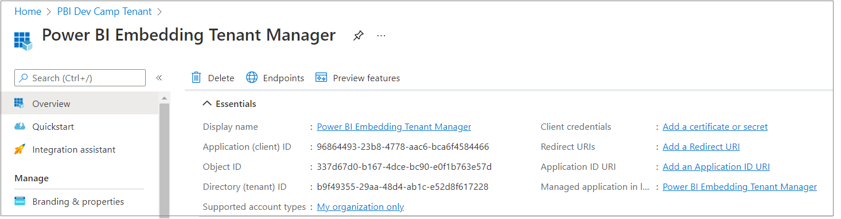

Copy the **Tenant ID** (aka Directory ID) and paste it into a text document so you can use it later in the setup process. Note that this **Tenant ID** value will be used by **AppOwnsDataMultiTenant** project to configure authentication with Azure AD.

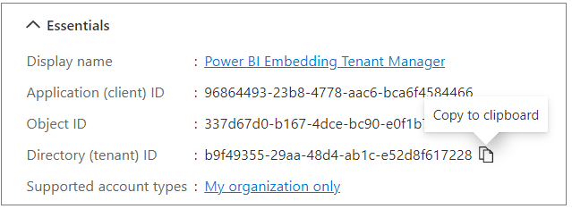

Next, repeat the same step by copying the **Client ID** and copying that into the text document as well.

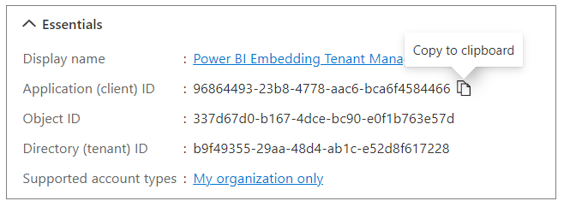

Your text document should now contain the  **Tenant ID** and **Client ID**  as shown in the following screenshot.

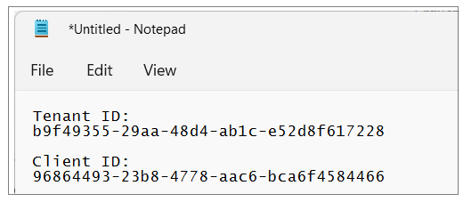

Next, you need to create a Client Secret for the application. Click on the **Certificates & secrets** link in the left navigation to move to the **Certificates & secrets** page. On the **Certificates & secrets** page, click the **New client secret** button as shown in the following screenshot.

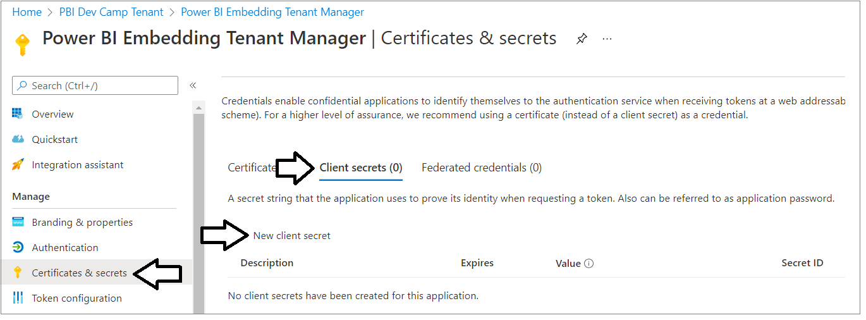

In the **Add a client secret** dialog, add a text description such as **Test Secret** and then click the **Add** button to create the new Client Secret.

](https://github.com/PowerBiDevCamp/TenantManagement/blob/main/Images/ReadMe/media/image20.png)

Once you have created the Client Secret, you should be able to see its **Value** in the **Client secrets** section. Click on the **Copy to clipboard** button to copy the Client Secret into the clipboard.

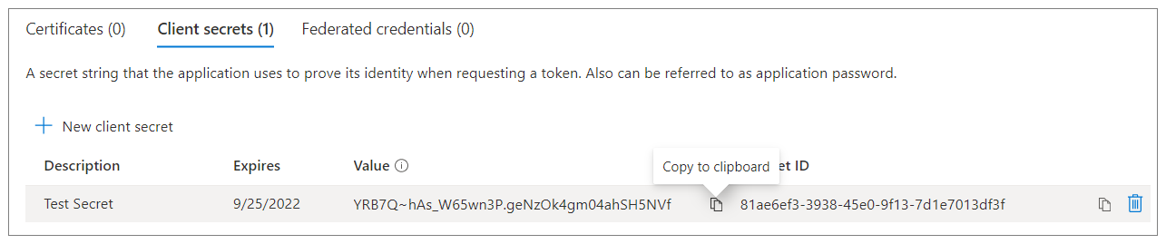

Paste the **Client Secret** into the same text document with the **Client ID** and **Tenant ID**.

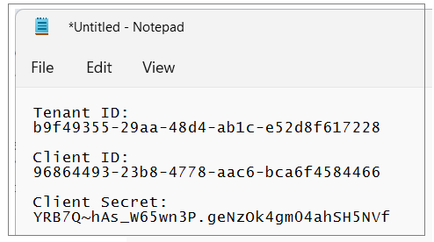

Xxxx

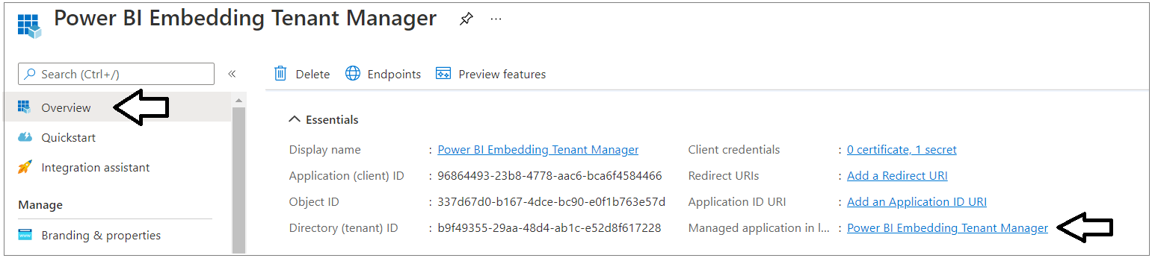

Xxxxxxxxx

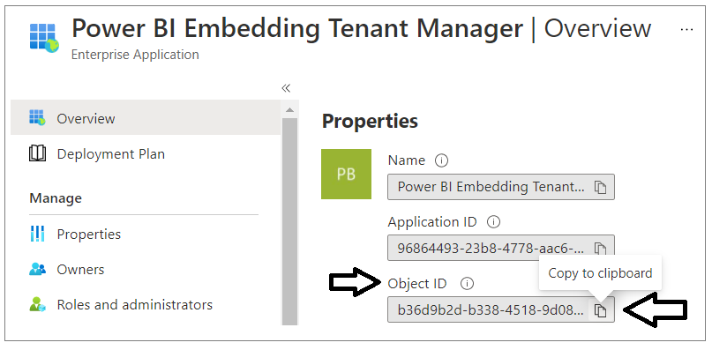

Xxxxx

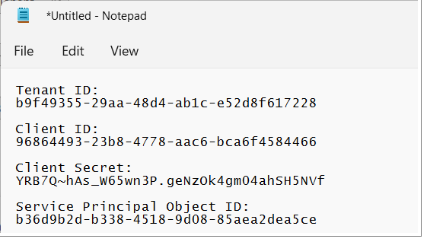

## Test the Tenant Management project in Visual Studio 2022

In order to run and test the **AppOwnsDataMultiTenant** project on a developer workstation, you must install the .NET 6 SDK and/or Visual Studio 2022. While this document will walk through the steps of opening and running the **AppOwnsDataMultiTenant** project using Visual Studio 2022, you can also open and run the project using Visual Studio Code if you prefer that IDE. Here are links to download this software if you need them.

1. .NET 6 SDK – [**download**]
2. Visual Studio 2022 – [**download**]
3. Visual Studio Code – [**download**]

### Download the Source Code

The source code for the **AppOwnsDataMultiTenant** project is maintained in a GitHub repository at the following URL.

[**https://github.com/PowerBiDevCamp/AppOwnsDataMultiTenant**](https://github.com/PowerBiDevCamp/TenantManagement)

You can download the **AppOwnsDataMultiTenant** project source files in a single ZIP archive using [this link](https://github.com/PowerBiDevCamp/AppOwnsDataMultiTenant/archive/refs/heads/main.zip). If you are familiar with the **git** utility, you can clone the project source files to your local developer workstation using the following **git** command.

git clone https://github.com/PowerBiDevCamp/AppOwnsDataMultiTenant.git

Once you have downloaded the source files for the **AppOwnsDataMultiTenant** repository to your developer workstation, you will see there is a top-level project folder named **AppOwnsDataMultiTenant** which contains several files including a solution file named **AppOwnsDataMultiTenant.sln** and a project file named **AppOwnsDataMultiTenant.csproj**.

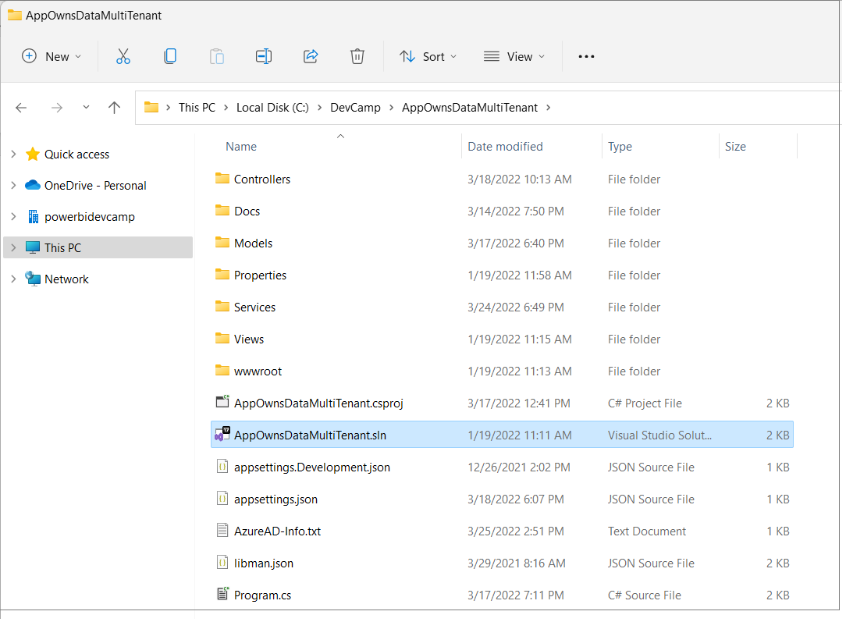

### Open the Project in Visual Studio 2022

Launch Visual Studio 2019 and use the **File > Open > Project/Solution** menu command to open the solution file named **AppOwnsDataMultiTenant.sln**. You should note that this development project has been built as a .NET 6 MVC Web Application as shown in the following screenshot.

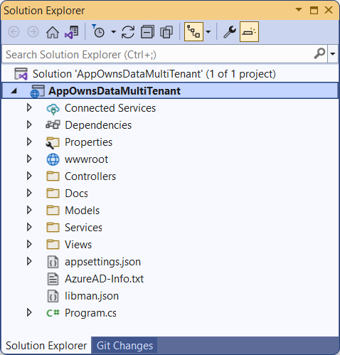

Let's quickly review the NuGet packages that have been installed in the **AppOwnsDataMultiTenant** project. There are several NuGet packages which add Entity Framework support which make it possible to quickly create the SQL Server database associated with this project.

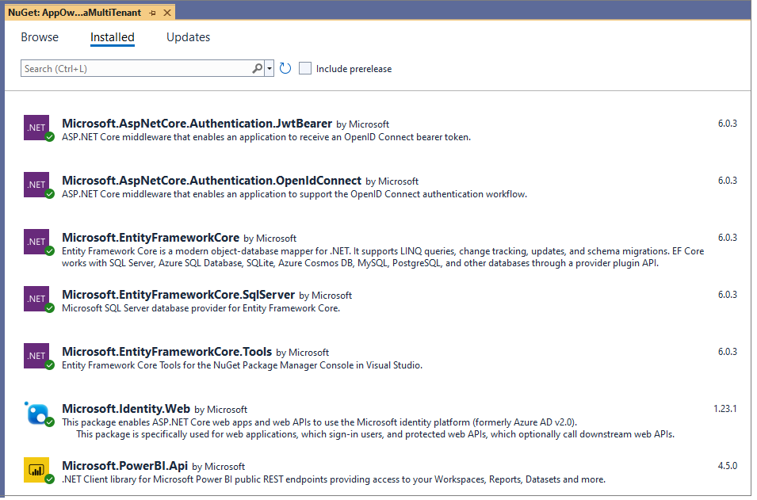

There are several packages included to add Azure AD authentication support including **Microsoft.Identity.Web** . The package named **Microsoft.PowerBI.Api** has been included to support .NET programming with the Power BI REST API.

### Update application settings in the appsettings.json file

Before you can run the application in the Visual Studio debugger, you must update several critical application settings in the **appsettings.json** file. Open the **appsettings.json** file and examine the JSON content inside. There is three important sections named **AzureAd**, **AppOwnsDataMultiTenantDB** and **DemoSettings**.

](https://github.com/PowerBiDevCamp/TenantManagement/blob/main/Images/ReadMe/media/image27.png)

Inside the **AzureAd** section, update the **TenantId**, **ClientId** and **ClientSecret** with the data you collected when creating the Azure AD application named **Power BI Tenant Management Application.**

](https://github.com/PowerBiDevCamp/TenantManagement/blob/main/Images/ReadMe/media/image28.png)

If you are using Visual Studio 2019, you shoukd be able leave the database connection string the way it is with the **Server** setting of **(localdb)\\MSSQLLocalDB**. You can change this connection string to point to a different server if you'd rather create the project database named **AppOwnsDataMultiTenantDB** in a different location.

](https://github.com/PowerBiDevCamp/TenantManagement/blob/main/Images/ReadMe/media/image29.png)

In the **DemoSettings** section there is a property named **AdminUser**. The reason that this property exists has to with you being able to see Power BI workspaces as they are created by service principals. There is code in the **AppOwnsDataMultiTenant** application that will add the user specified by the **AdminUser** setting as a workspace admin any times it creates a new Power BI workspace. This just makes things much easier for you to see what's going on when you begin to run and test the application.

Update the **AdminUser** setting with your Azure AD account name so that you will be able to see all the Power BI workspaces created by this application.

](https://github.com/PowerBiDevCamp/TenantManagement/blob/main/Images/ReadMe/media/image30.png)

### Create the ****AppOwnsDataMultiTenantDB**** database

Before you can run the application in Visual Studio, you must create the project database named **AppOwnsDataMultiTenantDB**. This database schema has been created using the .NET 5 version of the Entity Framework. In this step, you will execute two PowerShell cmdlets provided by Entity Framework to create the database.

Before creating the **AppOwnsDataMultiTenantDB** database, take a moment to understand how it’s been structured. Start by opening the file named **AppOwnsDataMultiTenantDB.cs** in the **Models** folder. Note that you shouldn't make any change to **AppOwnsDataMultiTenantDB.cs**. You are just going to inspect the file you understand how the **AppOwnsDataMultiTenantDB** database is generated.

](https://github.com/PowerBiDevCamp/TenantManagement/blob/main/Images/ReadMe/media/image31.png)

When you inspect the code inside **AppOwnsDataMultiTenantDB.cs**, you will see a class named **AppOwnsDataMultiTenantDB** that derives from **DbContext** to add support for automatic database generation using Entity Framework. The **AppOwnsDataMultiTenantDB** class serves as the top-level class for the Entity Framework which contains two **DBSet** properties named **AppIdentites** and **Tenants**. When you generate the database, each of these **DBSet** properties will be created as database tables. The **AppIdentites** table is generated using the table schema defined by the **PowerBiAppIdentity** class.

](https://github.com/PowerBiDevCamp/TenantManagement/blob/main/Images/ReadMe/media/image32.png)

The **Tenants** table is generated using the table schema defined by the **PowerBiTenant** class.

](https://github.com/PowerBiDevCamp/TenantManagement/blob/main/Images/ReadMe/media/image33.png)

After you have inspected the code used to generated the database, close the source file named **AppOwnsDataMultiTenantDB.cs** without saving any changes. The next step is to run the PowerShell commands to create the project database named **AppOwnsDataMultiTenantDB**.

Open the Package Manager console using **Tools > NuGet Package Manager > Package Manager Console**.

](https://github.com/PowerBiDevCamp/TenantManagement/blob/main/Images/ReadMe/media/image34.png)

You should see the **Package Manager Console** command prompt where you can execute PowerShell commands.

](https://github.com/PowerBiDevCamp/TenantManagement/blob/main/Images/ReadMe/media/image35.png)

Type and execute the following **Add-Migration** command to create a new Entity Framework migration in the project.

Add-Migration InitialCreate

The **Add-Migration** command should run without errors. If this command fails you might have to modify the database connection string in **appsettings.json**.

](https://github.com/PowerBiDevCamp/TenantManagement/blob/main/Images/ReadMe/media/image36.png)

After running the Add-Migration command, you will see a new folder has been added to the project named **Migrations** with several C# source files. There is no need to change anything in thee source files but you can inspect what's inside them if you are curious how the Entity Framework does its work.

](https://github.com/PowerBiDevCamp/TenantManagement/blob/main/Images/ReadMe/media/image37.png)

Return to the **Package Manager Console** and run the following **Update-Database** command to generate the database named **AppOwnsDataMultiTenantDB**.

Update-Database

The **Update-Database** command should run without errors and generate the database named **AppOwnsDataMultiTenantDB**.

](https://github.com/PowerBiDevCamp/TenantManagement/blob/main/Images/ReadMe/media/image38.png)

In Visual Studio, you can use the **SQL Server Object Explorer** to see the database that has just been created. Open the **SQL Server Object Explorer** by invoking the **View >** **SQL Server Object Explorer** menu command.

](https://github.com/PowerBiDevCamp/TenantManagement/blob/main/Images/ReadMe/media/image39.png)

Expand the **Databases** node for the server you are using and verify you an see the new database named **AppOwnsDataMultiTenantDB**.

](https://github.com/PowerBiDevCamp/TenantManagement/blob/main/Images/ReadMe/media/image40.png)

If you expand the **Tables** node for **AppOwnsDataMultiTenantDB**, you should see the two tables named **AppIdentities** and **Tenants**.

](https://github.com/PowerBiDevCamp/TenantManagement/blob/main/Images/ReadMe/media/image41.png)

The **AppOwnsDataMultiTenantDB** database has now been set up and you are ready to run the application in the Visual Studio debugger.

## Test the Tenant Management Application

Launch the **AppOwnsDataMultiTenant** web application in the Visual Studio debugger by pressing the **{F5}** key or clicking the Visual Studio **Play** button with the green arrow and the caption **IIS Express**.

](https://github.com/PowerBiDevCamp/TenantManagement/blob/main/Images/ReadMe/media/image42.png)

When the application starts, click the **Sign in** link in the upper right corner to begin the user login sequence.

](https://github.com/PowerBiDevCamp/TenantManagement/blob/main/Images/ReadMe/media/image43.png)

The first time you authenticate with Azure AD, you'll be prompted with the **Permissions requested** dialog asking you to accept the delegated permissions for the Microsoft Graph API requested by the application. Click the **Accept** button to grant these permissions and continue.

](https://github.com/PowerBiDevCamp/TenantManagement/blob/main/Images/ReadMe/media/image44.png)

Once you have logged in, you should see your name in the welcome message.

](https://github.com/PowerBiDevCamp/TenantManagement/blob/main/Images/ReadMe/media/image45.png)

### Create App Identities

Start by creating a few new App Identities. Click the **App Identities** link to navigate to the **App Identities** page.

](https://github.com/PowerBiDevCamp/TenantManagement/blob/main/Images/ReadMe/media/image46.png)

Click the **Add New App Identity to Pool** button to display the **Create New App Identity** page.

](https://github.com/PowerBiDevCamp/TenantManagement/blob/main/Images/ReadMe/media/image47.png)

When you open the **Create New App Identity** page, it will automatically populate the **App Identity Name** textbox with a value of **ServicePrincipal01**. Click the **Add New App Identity to Pool** button to create the new app identity.

](https://github.com/PowerBiDevCamp/TenantManagement/blob/main/Images/ReadMe/media/image48.png)

After a few second, you should see the new app identity named **ServicePrinicpal01** on the **App Identities** page.

](https://github.com/PowerBiDevCamp/TenantManagement/blob/main/Images/ReadMe/media/image49.png)

Follow the same steps to create two more app identities named **ServicePrincipal02** and **ServicePrincipal03**. When you're done, the **App Identities** page should match the following screenshot.

](https://github.com/PowerBiDevCamp/TenantManagement/blob/main/Images/ReadMe/media/image50.png)

Note that behind the scenes the **AppOwnsDataMultiTenant** application is using the Microsoft Graph API to create new Azure AD application each time you create a new app identity. If you return pack to the [App registration page](https://portal.azure.com/#blade/Microsoft_AAD_IAM/ActiveDirectoryMenuBlade/RegisteredApps) in the Azure portal, you will see that an Azure AD application has been created for each app identity you've created.

](https://github.com/PowerBiDevCamp/TenantManagement/blob/main/Images/ReadMe/media/image51.png)

If you return to the [Groups](https://portal.azure.com/#blade/Microsoft_AAD_IAM/GroupsManagementMenuBlade/AllGroups) page in the Azure portal and drill into the **Members** page of the **Power BI Apps** security group, you will see that the **AppOwnsDataMultiTenant** application has also added the service principal for each azure AD application as a group member. This is important because these service principals must be added to this Azure AD security group or they will not be able to call the Power BI REST API.

](https://github.com/PowerBiDevCamp/TenantManagement/blob/main/Images/ReadMe/media/image52.png)

In addition to communicating with Azure AD to create and configure Azure AD application, the **AppOwnsDataMultiTenant** application also captures application metadata and authentication credentials so it can store them in the **AppOwnsDataMultiTenantDB** database. Soon you will see how the **AppOwnsDataMultiTenant** application is able to retrieve these credentials on demand and authenticate with Azure AD under the identity of any of these Azure AD applications.

](https://github.com/PowerBiDevCamp/TenantManagement/blob/main/Images/ReadMe/media/image53.png)

**CAVEAT**: Keep in mind that the **AppOwnsDataMultiTenant** application has been designed as a proof-of-concept (POC) application to teach concepts and provide a starting point for other developers. This application does not include certain aspects that are important to include in a real-world applications such as hiding secrets. If you plan to extend this POC sample application into a production application, it will be your responsibility to add support for hiding credentials such as the Client Secret. You can consider an approach such as using the [Always Encrypted](https://docs.microsoft.com/en-us/sql/relational-databases/security/encryption/always-encrypted-database-engine?view=sql-server-ver15) feature in Azure SQL or extending the **AppOwnsDataMultiTenant** application to store client secrets or client certificates in [Azure Key Vault](https://docs.microsoft.com/en-us/azure/key-vault/general/basic-concepts).

### Create New Power BI Tenants

Return to the **AppOwnsDataMultiTenant** application and navigate to the **Tenants** page.

](https://github.com/PowerBiDevCamp/TenantManagement/blob/main/Images/ReadMe/media/image54.png)

Click the **Onboard New Tenant** button to display the **Onboard New Tenant** page.

](https://github.com/PowerBiDevCamp/TenantManagement/blob/main/Images/ReadMe/media/image55.png)

You can create the first tenant using the default values supplied by the **Onboard New Tenant** page. Click to **Create New Tenant** button to begin the process of creating a new customer tenant.

](https://github.com/PowerBiDevCamp/TenantManagement/blob/main/Images/ReadMe/media/image56.png)

After a few seconds, you should see the new customer tenant has been created.

](https://github.com/PowerBiDevCamp/TenantManagement/blob/main/Images/ReadMe/media/image57.png)

Click the **Onboard New Tenant** button again to create a second tenant.

](https://github.com/PowerBiDevCamp/TenantManagement/blob/main/Images/ReadMe/media/image58.png)

This time, select a different database for **Database Name** and then click **Create New Tenant**.

](https://github.com/PowerBiDevCamp/TenantManagement/blob/main/Images/ReadMe/media/image59.png)

You should now have two customer tenants. Note they each tenant has a different app identity as its **Owner**.

](https://github.com/PowerBiDevCamp/TenantManagement/blob/main/Images/ReadMe/media/image60.png)

Follow the same steps to create two more customer tenants so that there are 3 app identities and 4 customer tenants. Once you have created more tenants then app identities, you should see app identity pooling where multiple customer tenants share the same app identity.

](https://github.com/PowerBiDevCamp/TenantManagement/blob/main/Images/ReadMe/media/image61.png)

Now let's discuss what's going on behind the scenes. As you create a new customer tenant, the **AppOwnsDataMultiTenant** application uses the Power BI REST API to implement the following onboarding logic.

1. Create a new Power BI workspace
2. Upload a [template PBIX file](https://github.com/PowerBiDevCamp/TenantManagement/raw/main/TenantManagement/wwwroot/PBIX/DatasetTemplate.pbix) to create the **Sales** dataset and the **Sales** report
3. Update dataset parameters on **Sales** dataset to point to this customer's database
4. Patch credentials for the SQL datasource used by the **Sales** dataset
5. Start a refresh operation on the **Sales** database

The **AppOwnsDataMultiTenant** application also create a new record in the **Tenants** table of the **AppOwnsDataMultiTenantDB** database. Note that the application identity associated with this customer tenant is tracked in the **Owner** column.

[](https://github.com/PowerBiDevCamp/TenantManagement/blob/main/Images/ReadMe/media/image62.png)

Click on the **View** button for a specific tenant on the **Power BI Tenants** page to drill into the **Tenant Details** page.

](https://github.com/PowerBiDevCamp/TenantManagement/blob/main/Images/ReadMe/media/image63.png)

The **Tenant Details** page displays Power BI workspace details including its members, datasets and reports.

](https://github.com/PowerBiDevCamp/TenantManagement/blob/main/Images/ReadMe/media/image64.png)

Click on the back arrow to return to the **Power BI Tenants** page.

](https://github.com/PowerBiDevCamp/TenantManagement/blob/main/Images/ReadMe/media/image65.png)

If you're interested, you can examine the details of other tenants as well.

### Embed Reports

Now it's time to make use of the **AppOwnsDataMultiTenant** application's ability to embed reports. When navigate to the **Embed** page for a customer tenant, the **AppOwnsDataMultiTenant** application must acquire an access token for whichever app identity was used to create the customer tenant. The service principal that is configured as the **Owner** of a tenant will be the only service principal who will have access to access the target workspace in Power BI.

Move to the **Power BI Tenants** page and click on the **Embed** button for the first customer tenant.

](https://github.com/PowerBiDevCamp/TenantManagement/blob/main/Images/ReadMe/media/image66.png)

You should now see a page with an embedded report for that tenant. When you click the **Embed** button to embed a report for a customer tenant, the **TenanantManagement** application retrieves credentials for the app identity associated with the tenant from the **AppOwnsDataMultiTenantDB** database. It then uses those credentials to acquire an access token from Azure AD using Client Credentials Flow. That access token is then used to communicate with the Power BI Service to retrieve report metadata and generate an embed token for the embedding process.

](https://github.com/PowerBiDevCamp/TenantManagement/blob/main/Images/ReadMe/media/image67.png)

Click on the back arrow button to return to the **Tenants** page.

](https://github.com/PowerBiDevCamp/TenantManagement/blob/main/Images/ReadMe/media/image68.png)

Now test clicking the **Embed** button for other customer tenants. As you can see, the **AppOwnsDataMultiTenant** application has the ability to acquire access tokens for any of the Azure AD applications that it has created.

](https://github.com/PowerBiDevCamp/TenantManagement/blob/main/Images/ReadMe/media/image69.png)

### Inspect the Power BI Workspaces

If you're curious about what's been created in Power BI, you can see for yourself by navigating to the Power BI Service portal at [https://app.powerbi.com](https://app.powerbi.com/). You should be able to see and navigate to any of the Power BI workspaces that have been created by the **AppOwnsDataMultiTenant** application.

](https://github.com/PowerBiDevCamp/TenantManagement/blob/main/Images/ReadMe/media/image70.png)

Navigate to one of these workspaces such as **Tenant01**.

](https://github.com/PowerBiDevCamp/TenantManagement/blob/main/Images/ReadMe/media/image71.png)

Drill into the **Setting** page for the dataset named **Sales**.

](https://github.com/PowerBiDevCamp/TenantManagement/blob/main/Images/ReadMe/media/image72.png)

You should be able to verify that the **Sales** dataset has been configured by one of the Azure AD applications that was created by the **AppOwnsDataMultiTenant** application. You should also be able to see the **Last refresh succeeded** message for the dataset refresh operation that was started by the **AppOwnsDataMultiTenant** as part of its tenant onboarding logic.

](https://github.com/PowerBiDevCamp/TenantManagement/blob/main/Images/ReadMe/media/image73.png)

### Create a Separate Service Principal for Each Tenant

At this point you have used the **AppOwnsDataMultiTenant** application to pool app identities where one service principal can be the owner of multiple customer tenants. While this approach will work for many organizations and ISVs using Power BI embedding, you can take things one step further by creating a new service principal each time you create a new customer tenant. An application design which maintains a one-to-one relation between service principals and customer tenants will provide the most secure level of isolation. When you pool a service principal across tenants, that service principal will be the owner of datasource credentials for more than a single client.

When creating a new customer tenant using the **Onboard New Tenant** page, you can select the option to **Create Tenant using New Exclusive App Identity**. If you select this option, the **AppOwnsDataMultiTenant** application will create a new Azure AD application and then use the service principal from that application to create the workspace in Power BI.

](https://github.com/PowerBiDevCamp/TenantManagement/blob/main/Images/ReadMe/media/image74.png)

You should take note that The **AppIdentities** table in the **AppOwnsDataMultiTenantDB** database contains a boolean column named **Exclusive**. When an app identity has an **Exclusive** column value of **true**, there is logic in the application which knows it should not include that app identity in the pool of app identities available on the **Onboard New Tenant** page.

](https://github.com/PowerBiDevCamp/TenantManagement/blob/main/Images/ReadMe/media/image76.png)

This concludes the walkthrough of the **AppOwnsDataMultiTenant** application.